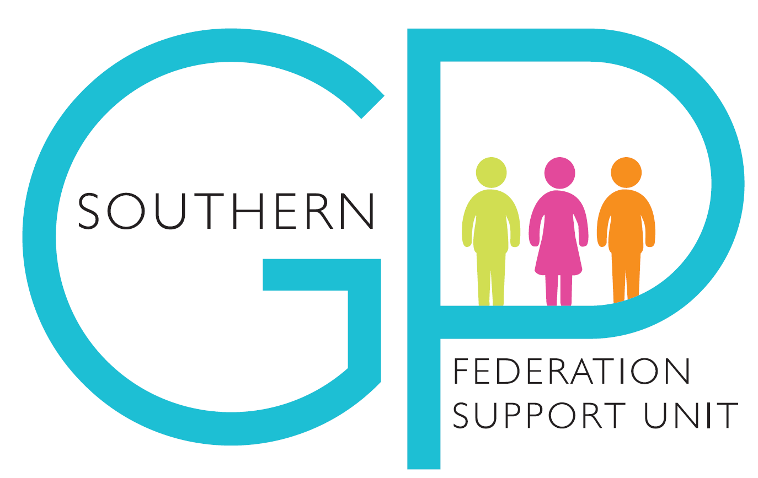

**Guidance – Working and Pregnancy during Covid-19**

**1. Working and Pregnancy during Covid-19**

All pregnant women must have a risk assessment carried out with their line manager. Risk assessments should be reviewed on a regular basis.

**Please see the New and Expectant Mothers Risk Assessment and Covid Risk Assessment Documents.**

The Royal College of Obstetricians & Gynaecologists (RCOG) guidance, ‘Coronavirus (COVID-19) Infection in Pregnancy, Information for Healthcare Professionals’, can be found at: [www.rcog.org.uk/en/guidelines-research-services/guidelines/coronavirus-pregnancy](http://www.rcog.org.uk/en/guidelines-research-services/guidelines/coronavirus-pregnancy)

In addition to this guidance, the RCOG have provided further information in relation to ‘Occupational health advice for employers and pregnant women during the COVID-19 pandemic’. This can be found at [www.rcog.org.uk/en/guidelines-research-services/guidelines/coronavirus-pregnancy](http://www.rcog.org.uk/en/guidelines-research-services/guidelines/coronavirus-pregnancy)

The Royal College of Obstetricians & Gynecologists, Royal College of Midwives and Faculty of Occupational Medicine updated their occupational health advice for employers and pregnant women on 09 September 2020 and issued a joint statement to advise;

* Pregnant women of any gestation are at no more risk of contracting the virus than any other non-pregnant person who is in similar health
* For those women who are 28 weeks pregnant and beyond, there is an increased risk of becoming severely ill should you contract COVID-19 (this is true of any viral illness contracted, such as flu).
* Pregnant women have been included in the list of people at moderate risk as a precaution.  A risk assessment must be conducted and reasonable measures should be considered to minimise the risk of exposure to the virus, including providing suitable alternative work on the same terms and condition.  Occupational Health advice can be sought if necessary.

**2. Pregnant women under 28 weeks’ gestation**

Pregnant women under 28 weeks gestation with no underlying health conditions can continue to work if the risk assessment confirms that it is safe for them to do so. Risk assessments should be reviewed on a regular basis i.e., monthly or as a when a change necessitates review.

A pregnant woman under 28 weeks gestation may continue to work in a patient facing role if the risk assessment confirms that it is safe for them to do so. It is essential that infection prevention control advice regarding hand hygiene and appropriate PPE are strictly adhered to. Risk assessments should be reviewed on a regular basis.

**3. Pregnant women at 28 weeks’ gestation** **or with underlying health conditions at any gestation**

For pregnant women from 28 weeks’ gestation, or with underlying health conditions such as heart or lung disease, and/or from a BAME background who contract COVID-19 at any gestation, there is an increased risk of becoming seriously ill (this is true of any viral illness contracted including flu). Pregnant women more than 28 weeks’ gestation should therefore be particularly attentive to social distancing.

For pregnant women after 28 weeks’ gestation, or with underlying health conditions such as heart or lung disease at any gestation, they **should be advised to work from home where possible and avoid direct patient contact.**

**If after full consideration, a pregnant woman who is over 28 weeks gestation cannot be practicably facilitated to work at home and does not request to continue working in the workplace – please see below Section 4- Special Paid Leave after 28 weeks.**

If following a risk assessment and taking any further advice, the pregnant woman chooses to attend the workplace, it is essential that flexible and safe working arrangements are discussed and agreed with their line manager. It is recommended that pregnant women over 28 weeks gestation avoid patient facing roles and work in a non-clinical environment where a workplace assessment has taken place to ensure the risks from COVID-19 are managed as far as reasonably practicable.  Options may include undertaking telephone or videoconference consultations from the workplace.

If following a risk assessment, the pregnant women requests to continue working in a patient facing role, the line manager should discuss the risks and if necessary, seek further advice from Occupational Health.

**4. Employee Responsibilities**

As with any situation where Health & Safety at work is concerned, staff have a duty to take care of their own health and safety at work and co-operate with their employer to help everyone meet Health & Safety requirements. In terms of pregnancy this means participating in risk assessments with their manager and raising any concerns or changes to their situation with their manager which may impact on the risk assessment as they arise so they can be provided with the appropriate support.

**5. Manager responsibilities**

As soon as a staff member informs you, they are pregnant you should conduct the New and Expectant Mothers risk assessment and a specific COVID-19 risk assessment. It will be important to consider reasonable measures to minimise the risk of exposure to the virus, including providing suitable alternative work on the same terms and conditions if necessary.  Occupational Health advice can be sought if needed, please contact HR to discuss and facilitate this.

**Pregnant women under 28 weeks gestation** **with no underlying health conditions** can continue to attend their workplace if the risk assessment advises that it is safe for them to do so. If a pregnant woman wishes to continue in a patient facing role and the risk assessments support her decision to do so, her line manager should support her decision ensuring that all precautionary measures are in place with regular reviews agreed.

(NOTE Pregnant women of any gestation should not be required to continue working if this is not supported by the risk assessment.  This risk assessment must be regularly reviewed).

**Pregnant women after 28 weeks gestation or with underlying health conditions at any gestation**

The manager and staff member must meet prior to the 28-week period (24 weeks if feasible) and review the risk assessment.

For pregnant women after 28 weeks’ gestation, or with underlying health conditions such as heart or lung disease at any gestation, they should be advised to work from home where possible and avoid direct patient contact.

Bearing in mind the skills of our staff and the importance of the availability of those skills to patients, flexible home working arrangements should be considered including remote working, undertaking telephone or videoconference consultations and/or taking on administrative duties.  The manager should discuss these options with the staff member during a review of the risk assessment.

**Special Paid Leave after 28 weeks**

If *after full consideration*, a pregnant woman who is over 28 weeks gestation cannot be practicably facilitated to work at home due to lack of equipment, access to necessary IT systems, availability of alternative duties or another substantial reason, the employee may be put on a period of special paid leave which can be kept under review in case opportunities for working from home subsequently emerge.

Maternity leave for women on special paid leave will commence at week 36.

**Please contact HR before formally agreeing special paid leave.**

**Continuing to attend the workplace after 28 weeks**

If the staff member chooses to continue in the workplace after 28 weeks, it will be important to ensure they avoid patient facing roles. A workplace assessment must be undertaken to ensure the risks from COVID-19 are managed as far as reasonably practicable. Strict adherence to social distancing, infection prevention control advice regarding hand hygiene and appropriate PPE must be ensured.

If as above, following a risk assessment, the pregnant women makes a request to continue working in a patient facing role, the line manager should discuss the risks and if necessary seek further advice from Occupational Health.